**Analysis of snp500return**

**Stationarity Test**

H0: SNP500RETURN has a unit root

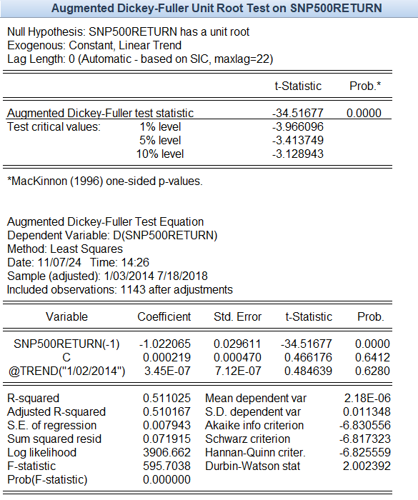H1: SNP500RETURN does not have a unit root

The ADF test has a probability of 0.0000 (less than 0.01), we reject the null hypothesis. SNP500RETURN does not have a unit root and is stationary.

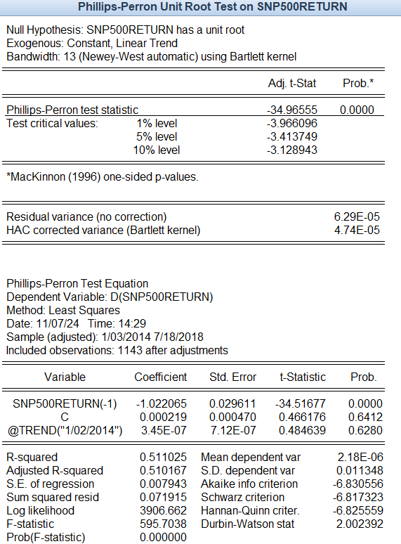

The PP test has a probability of 0.0000 (less than 0.01), we reject the null hypothesis. SNP500RETURN does not have a unit root and is stationary.

**Linearity Test**

1. Scatter Plot

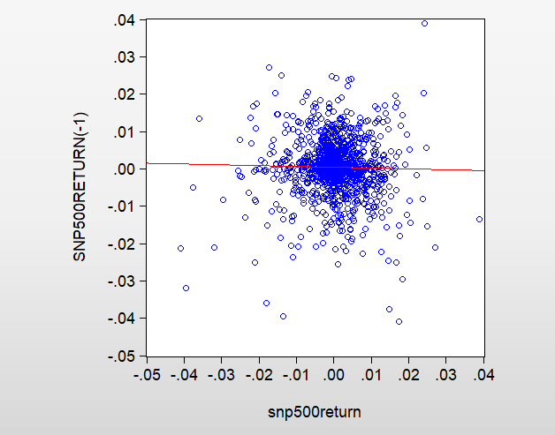

The plot does not show any pattern (either increasing or decreasing). Thus, we can conclude that the data is non-linear.

1. H0: The data is linear

H1: The data is non-linear

Since the probability of all the dimensions in BDS Test is 0.0000 (less than 0.01), we reject the null hypothesis. It is concluded that the data is non-linear. Thus, AR/MA/ARMA models are not suitable, and we have to use ARCH/GARCH model.

**ARCH(1) Model**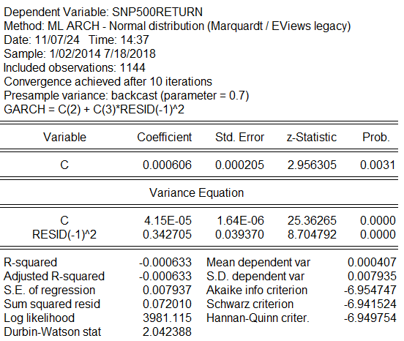

The probability of all the variables is significant (less than 0.01)

Significant ARCH(1) value implies that previous period shocks significantly influence current volatility, which is common feature in financial returns data.

The arch coefficient of 0.342705 suggests that if there was a shock in the previous period, its squared value is scaled by 0.342705 to affect the current variance.

**Diagnostic Test for ARCH (1)**

1. ARCH-LM Test

H0: No ARCH effect

H1: Have ARCH effect

1. Lag 1

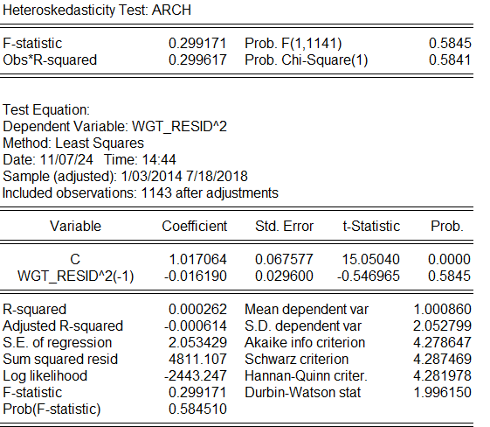

The probability is 0.5845 (>0.05), we fail to reject null hypothesis. Therefore, at lag 1, there is no ARCH effect.

1. Lag 2

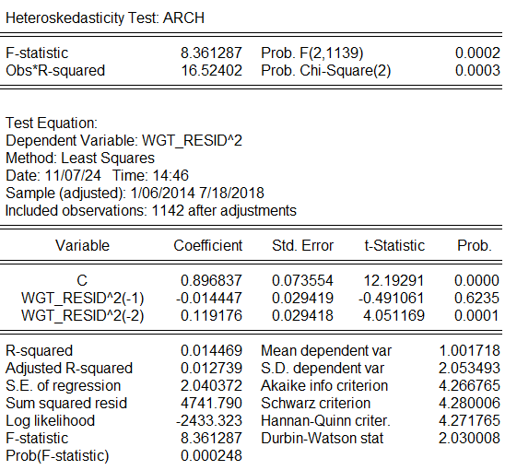

The probability is 0.0002 (<0.05), we reject the null hypothesis. Therefore, at lag 2, there is significant remaining ARCH effect. Our model fails to fully capture the persistence volatility clustering. GARCH model is required.

1. Ljung-Box Q Test

H0: No autocorrelation in squared residuals

H1: There is autocorrelation in squared residuals

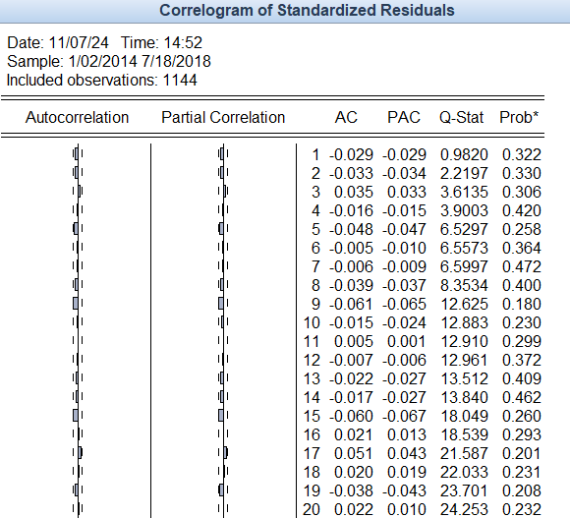

As lag increases, the probability is still more than 0.05, thus we fail to reject null hypothesis. There is no significant autocorrelation in squared residuals.

**GARCH (1,1)**

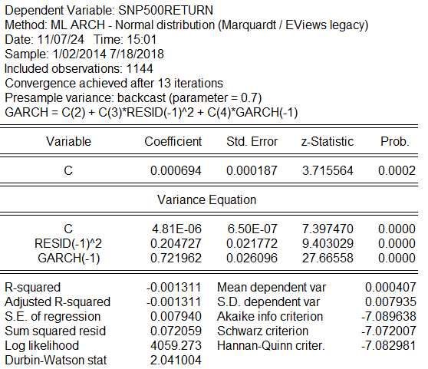

The probability of all the variables is significant (less than 0.01)

Significant ARCH coefficient implies that previous period shocks significantly influence current volatility, but smaller degree than in pure ARCH model.

The arch coefficient of 0.2047 suggests that if there was a shock in the previous period, its squared value is scaled by 0.2047 to affect the current variance.

The Garch coefficient of 0.7219 suggests strong persistence in volatility, meaning past volatility influences future volatility over a longer period.

**GARCH (1,2)**

The probability of all the variables is significant (less than 0.01) EXCEPT for GARCH(-2).

The arch coefficient of 0.2241 suggests that if there was a shock in the previous period, its squared value is scaled by 0.2241 to affect the current variance.

The GARCH (-1) coefficient of 0.5235 suggests strong persistence in volatility, meaning past volatility influences future volatility over a longer period.

The GARCH (-2) represents the volatility persistence from two periods ago. However, the probability of this term is 0.2964 (greater than 0.05), thus, the influence of past volatility from two periods ago on the current volatility is weak or negligible.

**Diagnostic Test for GARCH (1,1)**

1. ARCH-LM Test

H0: No ARCH effect

H1: Have ARCH effect

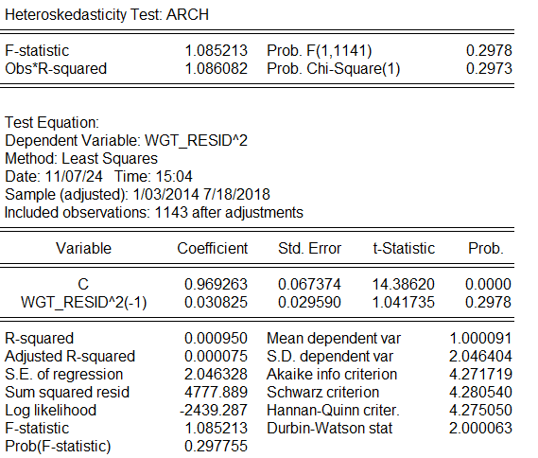

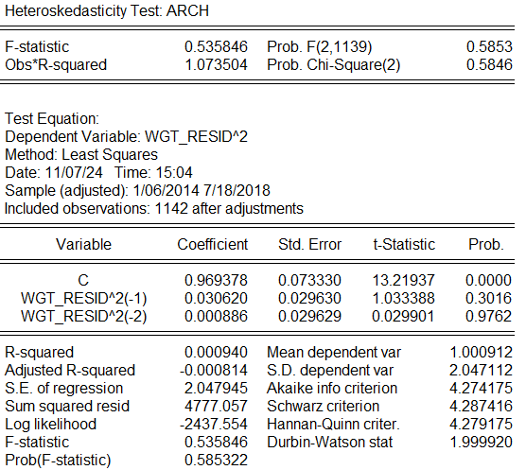

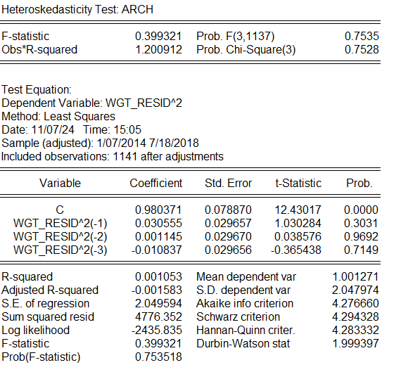

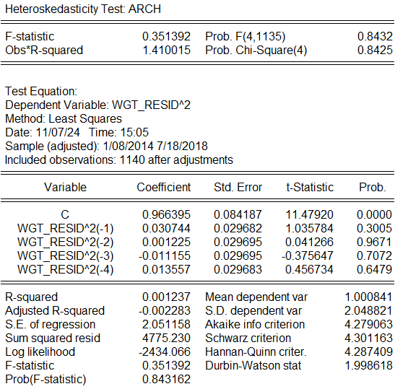

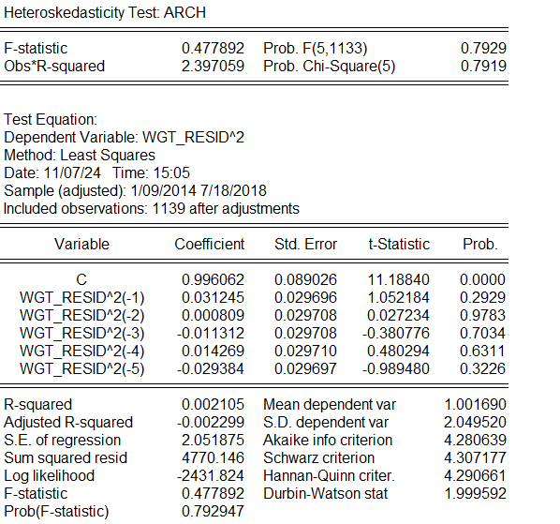

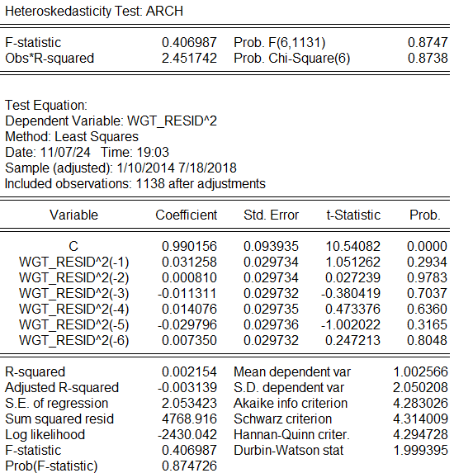

Since the probability value for ARCH-LM Test for lag 1 through lag 10 is greater than 0.05, we fail to reject null hypothesis. Thus, there are no ARCH effect.

1. Ljung-Box Q Test

H0: No autocorrelation in squared residuals

H1: There is autocorrelation in squared residuals

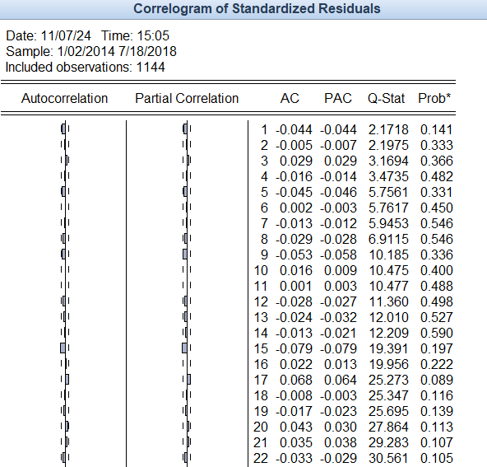

As lag increases, the probability is still more than 0.05, thus we fail to reject null hypothesis. There is no significant autocorrelation in squared residuals.

**Diagnostic Test for GARCH (1,2)**

1. ARCH-LM Test

H0: No ARCH effect

H1: Have ARCH effect

Since the probability value for ARCH-LM Test for lag 1 through lag 10 is greater than 0.05, we fail to reject null hypothesis. Thus, there are no ARCH effect.

1. Ljung-Box Q Test

H0: No autocorrelation in squared residuals

H1: There is autocorrelation in squared residuals

As lag increases, the probability is still more than 0.05, thus we fail to reject null hypothesis. There is no significant autocorrelation in squared residuals.

**Choosing the model**

|  |  |  |  |
| --- | --- | --- | --- |
| **MODEL** | **ARCH (1)** | **GARCH (1,1)** | **GARCH (1,2)** |
| **ALL VARIABLES** | **Significant** | **Significant** | **Significant except GARCH (-2)** |
| **ARCH EFFECT**  **(ARCH-LM)** | **Significant ARCH Effect at lag 2** | **None** | **None** |
| **AUTOCORRELATION OF SQUARED RESIDUALS**  **(LJUNG-BOX)** | **None** | **None** | **None** |
| **AIC** | **-6.9547** | **-7.0896** | **-7.0884** |
| **SIC** | **-6.9415** | **-7.0830** | **-7.0663** |

We ***choose GARCH (1,1***) due to all explanatory variables being significant. Also, it has no ARCH Effect not captured in the model and no autocorrelation of squared residuals. Furthermore, it has the lowest AIC and SIC. Additionally, it is the most parsimonious model.